IVY CREEK HOMEOWNER’S ASSOCIATION
ARCHITECTURAL AND LANDSCAPE REVIEW REQUEST

Please provide the following information:

Name of Association: IVY CREEK HOMEOWNER’S ASSOCIATION

Homeowner: ____________________________________Date:___________________

Street address: ________________________________, City:_____________________

Tele (day) ___________ (home) ___________ (email) __________________________

Builder/Contractor__________________________________ (tele) ________________ (Please note if you are an agent submitting on behalf of a homeowner.)

Expected start date: ____________ Expected completion date:____________________

I am applying for the following improvement(s) to my/our Lot. More than one box may be checked
o Deck
o Fence
- Landscape (trees, bushes, flowers) Hardscape (walkways, walls)
- Paint – Exterior (color chip required)
- Other (explain)____________________________________________________

All applications must include the following information if applicable. Incomplete applications will be returned.
- Plat Plan (Showing locations of improvements on the Lot, drawn to scale.)
- Floor Plans and Roof Design (if applicable).
- Materials and Finishes, Colors (Attach samples, paint chips, etc.) o Photos and Brochures (if available), Exterior elevations (scale drawings).
- Plant Selections (If applicable, include size, variety, etc.)

Please provide a description of the improvements to be made. (Use additional paper if necessary.)

Signature of Applicant:________________________________________________________________

_____________________________________________________________________________________
ARC USE ONLY:
_________Approved _________Not Approved _________Approved with Conditions
_______ Resubmit with additional information
Reviewer:

Submit Your Application to:
Email:
bryan@casnc.com
Mail:
Bryan Hardin-Casale
207 West Millbrook Rd.
Suite 110
Raleigh, NC
27609

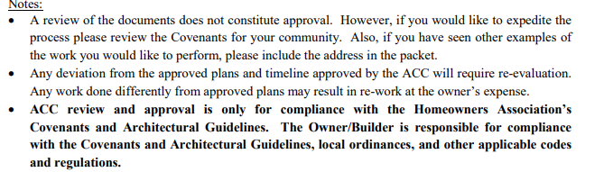
IF YOU HAVE ANY QUESTONS PLEASE CONTACT MY OFFICE AT 919-788-9911 EXT. 1600

